Preserving Heritage: Community Unites to Restore the Olde English Cemetery
The restoration efforts at the Olde English Cemetery reflect the deep commitment of the Town of Bath to preserving its historical legacy. Central to this endeavor is the dedicated work of the Ye Towne of Bath Chapter of the daughters of the American Revolution (DAR), whose efforts to clear, locate, and reset gravestones pay tribute to the town’s earliest settlers and notable residents.
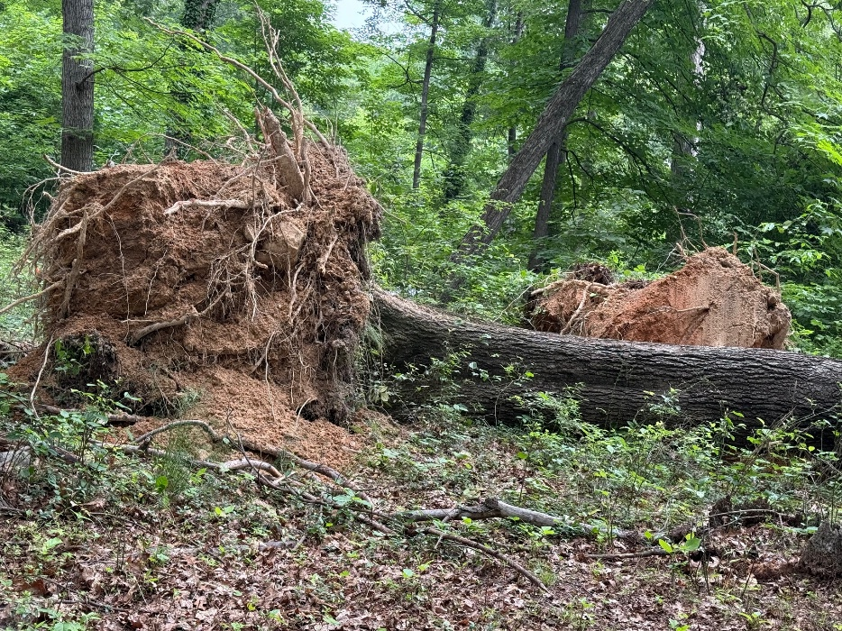
A recent initiative to remove a massive fallen red oak underscores the ongoing challenges of maintaining historic sites. This task was made possible through the collaboration of the DAR, the Town of Bath Tree Board, and Truax Tree Services, with generous donations supporting the project.

This collective action not only safeguards the cemetery’s physical integrity but also ensures its preservation for future generations. It stands as a testament to what a united community can achieve in honoring and protecting its shared heritage.
